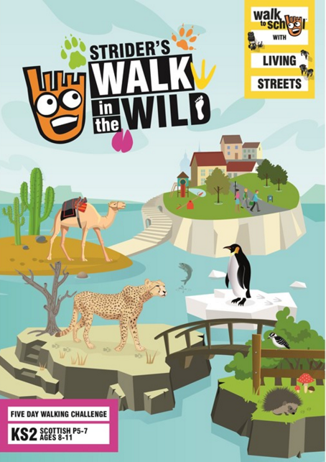

**Dress up as wild animal and join us on FRIDAY 20TH MAY at 8:40 in WALK TO SCHOOL FROM THE VILLAGE HALL**

**WALK TO SCHOOL WEEK**

**16-20 MAY**