March 2020
Music Fun At Home

Hello Year 2!

I hope you are enjoying learning at home! It is a little bit different to being in school, I am sure it is just as much fun!

I have found you some exciting music games to play, I hope you will enjoy trying out the different instrument sounds, beats and rhythms of the songs.

To find the games on your computer or table, you need to click here:

https://www.bbc.co.uk/teach/bring-the-noise/eyfs-ks1-music-play-it-bring-the-noise/z4sq92p

This is what the music lesson screen looks like:
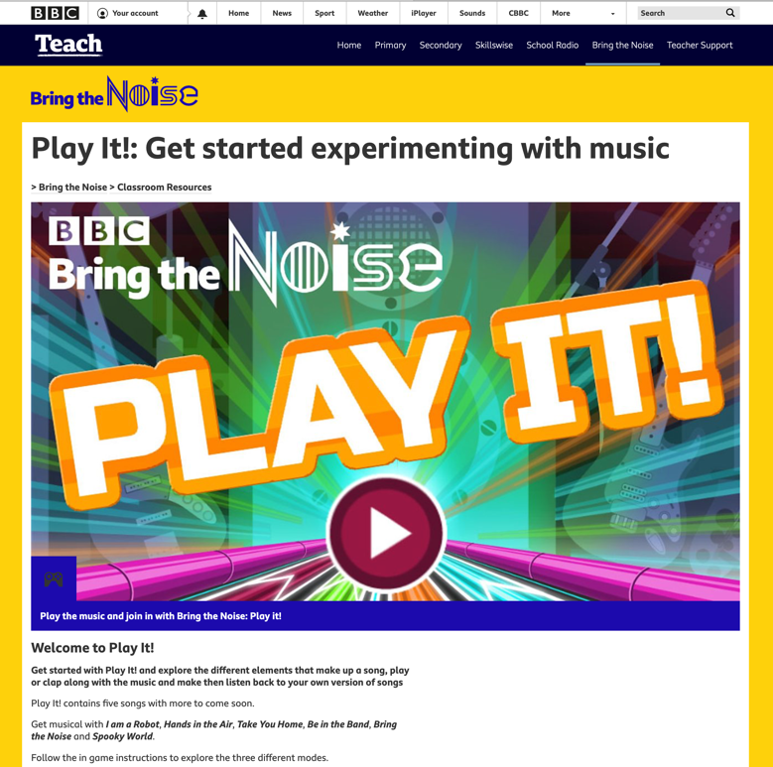

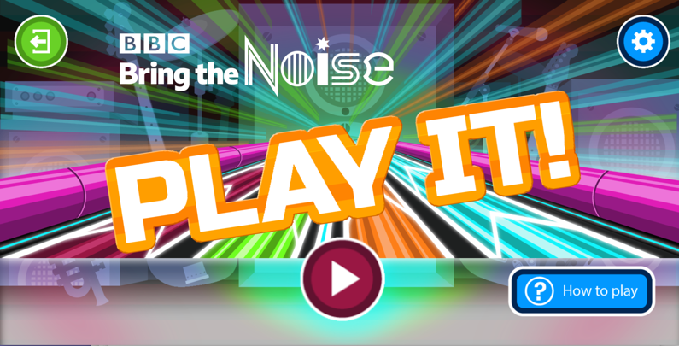
You will see the following screen:

Please click in the big circle arrow.

The next screen looks like this:
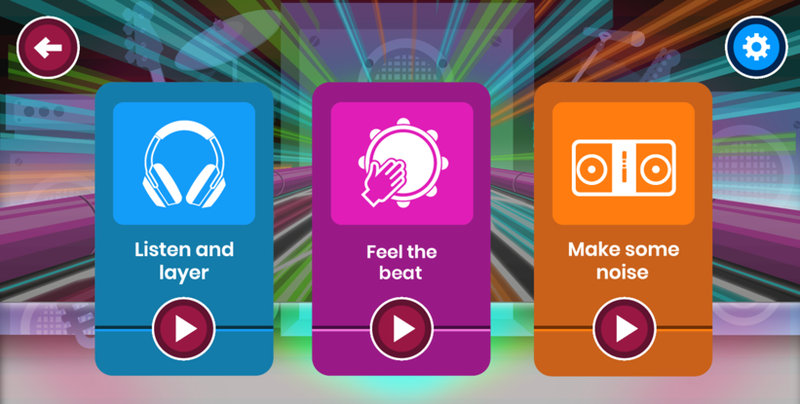

There are three areas to play:
- Listen and layer (blue)
- Feel the beat (purple)
- Make some noise (orange)

When you click on each area, there are eleven songs to listen to:
- I am a robot
- Dream on
- Music time
- Anything
- Far
- Be in the band
- Gathered round the Christmas tree
- Spooky world
- Hands in the air
- Bring the noise
- Take you home

Note to parents and carers: each lesson may take a few short lesson sessions, there is a lot to work on within each section.

Lesson One – Listen and layer
- In this lesson, you can hear different parts (or layers) of a song.
- The big buttons show the different layers – the parts that are playing together.
- Press the buttons to turn the layers off and on.
- Listen carefully to hear how the song changes, especially when you turn off the drum.
- What do you notice? What do you think?

Lesson Two – Feel the beat
- In this lesson, you can join in with the music.
- You will see hearts and dots moving across the screen.
- The speed the hearts are moving will tell you how fast the song is going, how quick the beat is.
- Can you dance or clap along to the beat?

Lesson Three – Make some noise
- In this section, you can add your own sounds and beats to the music.
- You can create rhythms (a pattern of sounds) or keep to the beat (the regular sound that keeps the music going and in time).
- Can you clap the beat? Can you clap the rhythm?

I hope you enjoy playing these games! Please let me know how you get on.

Mrs Sumner
hsumner@hughendenprimary.co.uk

