

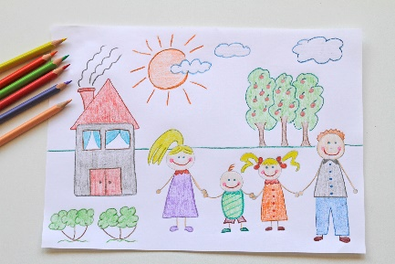 **October Half Term **

**Holiday Day**

**Based at Hughenden Primary School**

**HP14 4LR**

**Available to all children ages 3 to 11**

**Full Session: 8 AM – 5 PM**

**School Session: 8:30 AM – 3 PM**

**Opening Dates:**

**23/10/23 – 27/10/23**

**£34 for a full day or £30 for a school day**

**\*10% Sibling discount if booking more than one session.**

**Breakfast and Snacks will be provided.**

**Please bring a packed lunch and water bottle along with you.**

**\*Dietary Needs can be catered for. Please state on booking.**

**Activities to Include:**

**Arts & Crafts, Cookery, Film Club, Team Games & Free Play.**

***We are always led by the children’s interests.***

**To book your place please tick on the below link and sign up to our online booking system.**

[Schedule for Friends at Play (supersaas.com)](https://www.supersaas.com/schedule/Friends_at_Play_Hughenden/Friends_at_Play)